In this chapter, we will consider two example scenarios. These examples are easier to comprehend and will help us understand the way the ArangoDB functionality works.

To demonstrate the APIs, ArangoDB comes preloaded with a set of easily understandable graphs. There are two methods to create instances of these graphs in your ArangoDB −

* Add Example tab in the create graph window in the web interface,
* or load the module **@arangodb/graph-examples/example-graph** in Arangosh.

To start with, let us load a graph with the help of web interface. For that, launch the web interface and click on the **graphs** tab.

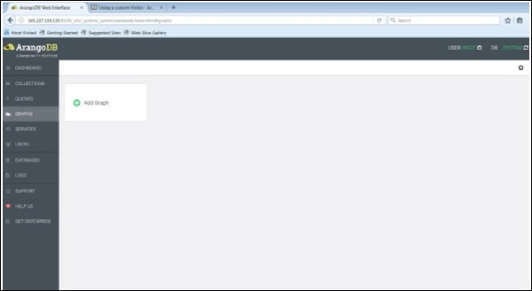

The **Create Graph** dialog box appears. The Wizard contains two tabs – **Examples** and **Graph**. The **Graph** tab is open by default; supposing we want to create a new graph, it will ask for the name and other definitions for the graph.

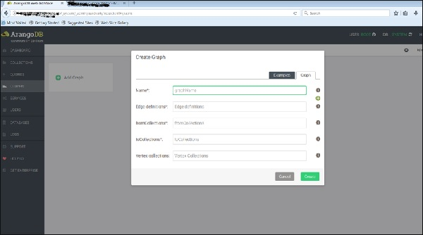

Now, we will upload the already created graph. For this, we will select the **Examples** tab.

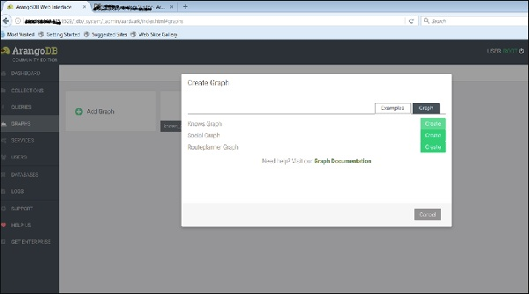

We can see the three example graphs. Select the **Knows_Graph** and click on the green button Create.

Once you have created them, you can inspect them in the web interface - which was used to create the pictures below.

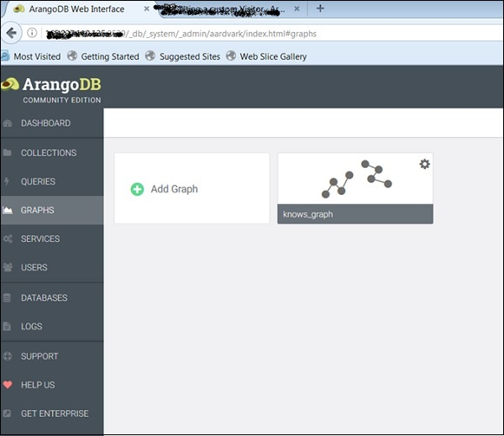

The Knows_Graph

Let us now see how the **Knows_Graph** works. Select the Knows_Graph, and it will fetch the graph data.

The Knows_Graph consists of one vertex collection **persons** connected via one edge collection **knows**. It will contain five persons Alice, Bob, Charlie, Dave and Eve as vertices. We will have the following directed relations

Alice knows Bob

Bob knows Charlie

Bob knows Dave

Eve knows Alice

Eve knows Bob

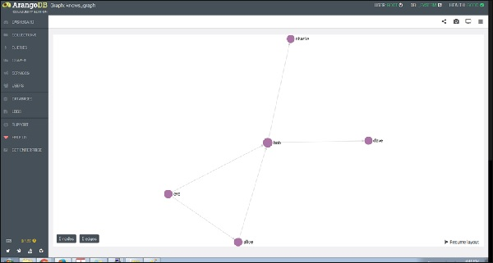

If you click a node (vertex), say ‘bob’, it will show the ID (persons/bob) attribute name.

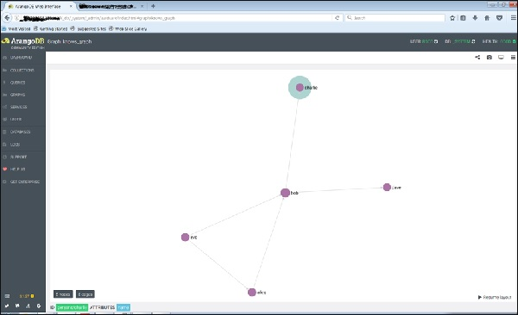

And on clicking any of the edge, it will show the ID (knows/4590) attributes.

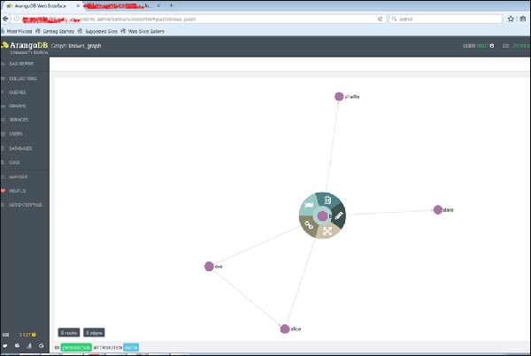

This is how we create it, inspect its vertices and edges.

Let us add another graph, this time using Arangosh. For that, we need to include another endpoint in the ArangoDB configuration file.

How to Add Multiple Endpoints

Open the configuration file −

# vim /etc/arangodb3/arangod.conf

Add another endpoint as shown in the terminal screenshot below.

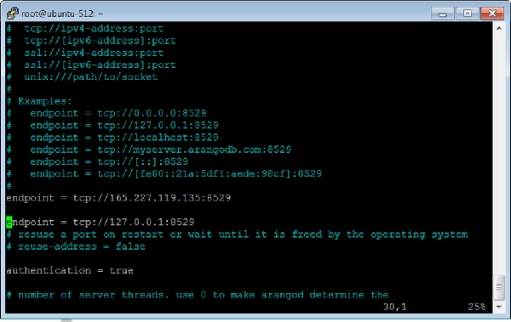

Restart the ArangoDB −

# service arangodb3 restart

Launch the Arangosh −

# arangosh

Please specify a password:

_

__ _ _ __ __ _ _ __ __ _ ___ ___| |__

/ _` | '__/ _` | '_ \ / _` |/ _ \/ __| '_ \

| (_| | | | (_| | | | | (_| | (_) \__ \ | | |

\__,_|_| \__,_|_| |_|\__, |\___/|___/_| |_|

|___/

arangosh (ArangoDB 3.1.27 [linux] 64bit, using VPack 0.1.30, ICU 54.1, V8

5.0.71.39, OpenSSL 1.0.2g 1 Mar 2016)

Copyright (c) ArangoDB GmbH

Pretty printing values.

Connected to ArangoDB 'http+tcp://127.0.0.1:8529' version: 3.1.27

[server], database: '_system', username: 'root'

Please note that a new minor version '3.2.2' is available

Type 'tutorial' for a tutorial or 'help' to see common examples

127.0.0.1:8529@_system>

The Social_Graph

Let us now understand what a Social_Graph is and how it works. The graph shows a set of persons and their relations −

This example has female and male persons as vertices in two vertex collections - female and male. The edges are their connections in the relation edge collection. We have described how to create this graph using Arangosh. The reader can work around it and explore its attributes, as we did with the Knows_Graph.